|  |  |  |  |  |
| --- | --- | --- | --- | --- |
| a |  | 110 Holly Street  Seaford, DE 19973  Phone: (302)270-9183  Fax: (302)629-7726  Email: ccaguidance@aol.com  The Phone Company | (206) 555‐0100 | info@thephone-company.com  www.thephone-company.com |  | **Course Catalog**  Cross Christian Academy  **Elementary/middle School** |

Subjects offered:

* English or Phonics (Kindergarten & First grade)
* Math
* Science
* History
* Physical Education
* Spelling
* Reading
* Bible
* Chapel
* Art
* Music

GRADING SYSTEM

A = 92-100

B = 83-91

C = 74-82

D = 65-73

F = 0-64

|  |  |  |  |  |
| --- | --- | --- | --- | --- |
| Use icons to add visual interest |  | Make It Yours To get started right away, just select any placeholder text (such as this) and start typing to replace it with your own.  No problem! The Themes, Colors, and Fonts galleries give you the option to add your own. |  | **Course Descriptions:**  **English (1 Credit, 4 required)**  Emphasizes grammar skills, beginning with sentence patterns, and going on to the eight parts of speech, phrases, and clauses. Each course expands on the skills and parts of speech.  **Math (1 credit, 4 required)**  Algebra I: Introduces basic algebraic skills in logical order, including relations, functions, graphing, systems of equations, radicals, factoring, rational equations, probability and statistics, and quadratic functions.  Geometry: Enhance your student’s problem-solving abilities through the study of Geometry. Each lesson reinforces geometry concepts and helps develop critical thinking skills.  Algebra 2: Focuses on developing reasoning skills through the discussions of advanced algebra concepts such as quadratic equations, polynomials, complex numbers, logarithms, and trigonometry.  Consumer Math: Helps students develop the knowledge and skills they need to successfully handle their personal finances. Topics include developing a budget, filing taxes, and planning a vacation.  **Foreign Language (1 credit, 2 required)**  Latin 1: An introduction to Latin that takes a logical, systematic approach to grammar and syntax. This facilitates retention and understanding to ensure skills mastery and rapid recognition.  Latin 2: Continues the journey of learning Latin grammar and encourages everyday translations. |

**Course Descriptions:**

**English/Phonics**

BJU Press's elementary English product line connects skills in writing, mechanics, listening, speaking, and viewing to provide students with a solid English language arts foundation. Students study one part of speech at a time, mastering English conventions through spiral review and regular practice of each skill.

**Math**

Equips students to master foundational math skills through hands-on manipulatives and sequential teaching that lead students from a concrete to an abstract understanding of mathematics. This process results in deep understanding and long-term retention of mathematical reasoning.

**P.E.**

Develops fundamental skills, team play, conditioning, strategy, and principals of personal health and fitness.

**Sciences**

While studying science from a biblical viewpoint, your children explore God's creation, investigating the far reaches of the universe, the structure and inhabitants of the earth, and the workings of cells and atomic reactions. Your children will see God's orderliness in both physical and biological systems.

**History**

Guides students in analyzing and evaluating historical events, world cultures, and primary sources from a biblical worldview.

**Bible**

The BJU Press elementary Bible program helps to bridge the gap between head knowledge and heart knowledge by guiding students as they study, interpret, and apply a biblical worldview. When students know God’s Word, their hearts can change to love and worship God and, in turn, love others as themselves. When the Word of God changes students’ minds, hearts, and actions, they can live like Christ and share the truth of the gospel with others.

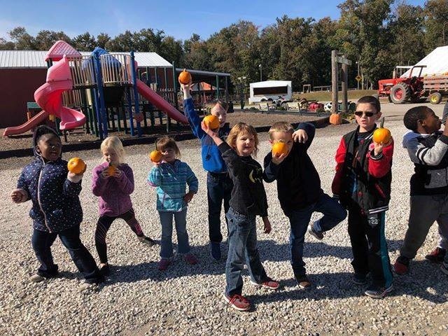

We offer extra-curricular activities such as; cheerleading, basketball, soccer, Pokémon, and more each year!



**Welcome to Cross Christian Academy**

The Cross Christian Academy provides an enriched learning environment that has helped countless students for 11 years. Founded in 2011, the private Christian school is in Seaford, Delaware and reflects the diverse backgrounds and cultures of the area. We’re extremely proud of our students and staff, who are always eager to learn, create and grow together. We thank you for your interest in becoming apart of the Centurion Family. The following brochure is a brief explanation of courses that are offered at the Cross Christian Academy. We look forward to meeting you.

We utilize Bob Jones University Press (BJU) for our curriculum to educate our young children which is described in this pamphlet.

Our staff members are caring, compassionate, and eager educators who specialize in skill sets that assist them in educating children. Whether that be nursing, biblical theology, a homeschool mother who taught her own children, a retired public school teacher, we all strive to guide the youth to their endless educational possibilities.